End-to-End Cloud Workflow: GitHub to Ubuntu EC2 Deployment using Docker and PM2
Virtual Private Cloud (VPC) :
VPC (Virtual Private Cloud) is a private, isolated network in AWS that allows you to securely run resources like EC2 instances.
You can control IP ranges, subnets, route tables, and gateways
Steps:
  - Go to VPC Dashboard → Create VPC.
  - Set IPv4 CIDR block (e.g., 10.0.0.0/16).
  - Create subnets (public for EC2, private if needed).
  - Create an Internet Gateway and attach it to your VPC.
  - Update route tables to allow internet access for public subnet
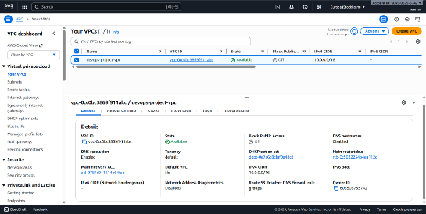
Launch an EC2 Instance
- Go to EC2 Dashboard → Launch Instance.
Choose Ubuntu
Attach the security group created
Generate and download key pair (.pem) for SSH.
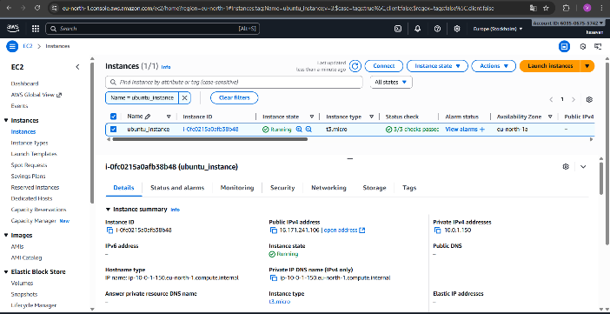
Docker Installation & Verification
Explanation:
Docker is a containerization platform — it runs apps in isolated environments (containers).
Commands:
sudo apt update
sudo apt install docker.io -y
docker –version
sudo systemctl enable docker
sudo systemctl start docker
sudo docker run hello-world
sudo docker run docker/whalesay cowsay "Hello Vira!"
sudo systemctl status docker
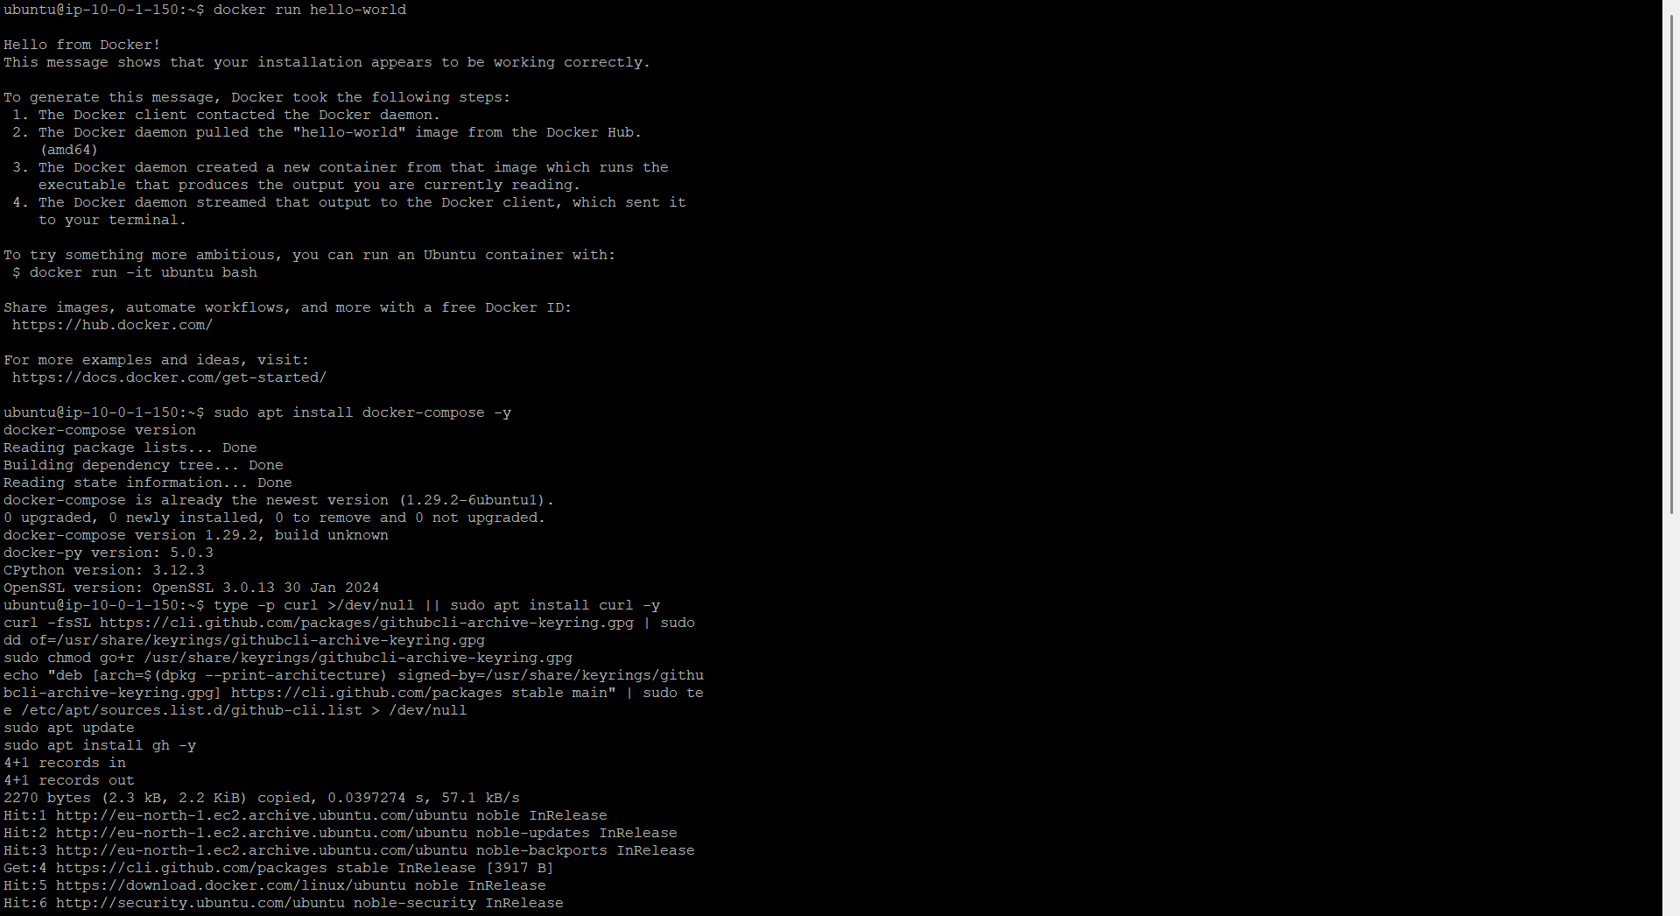
Run Docker Sample App (Cowsay Example)
Test with a small fun container:
sudo docker run docker/whalesay cowsay Hello World
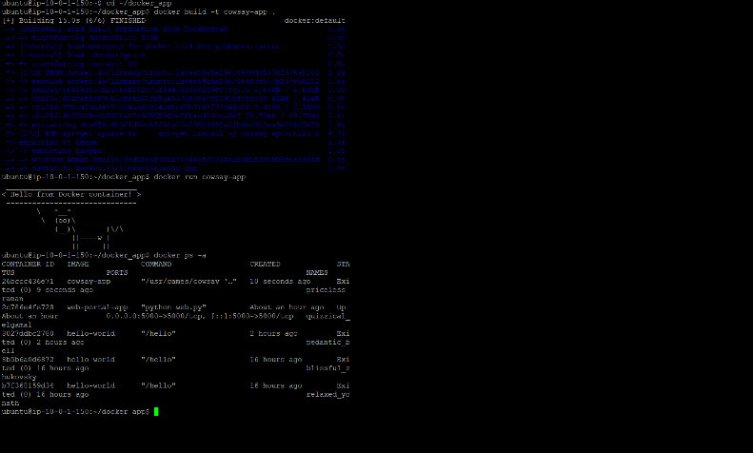

GitHub Authentication (Device Code Login)
Explanation:
Before pushing your code, GitHub must authenticate your device.
Commands:
git config --global user.name "virakesavanv"
git config --global user.email your@email.com
git remote add origin https://github.com/virakesavanv/hello-vira-nodejs.git
git push -u origin main
You’ll get a code → open GitHub login → enter code → authorize device. 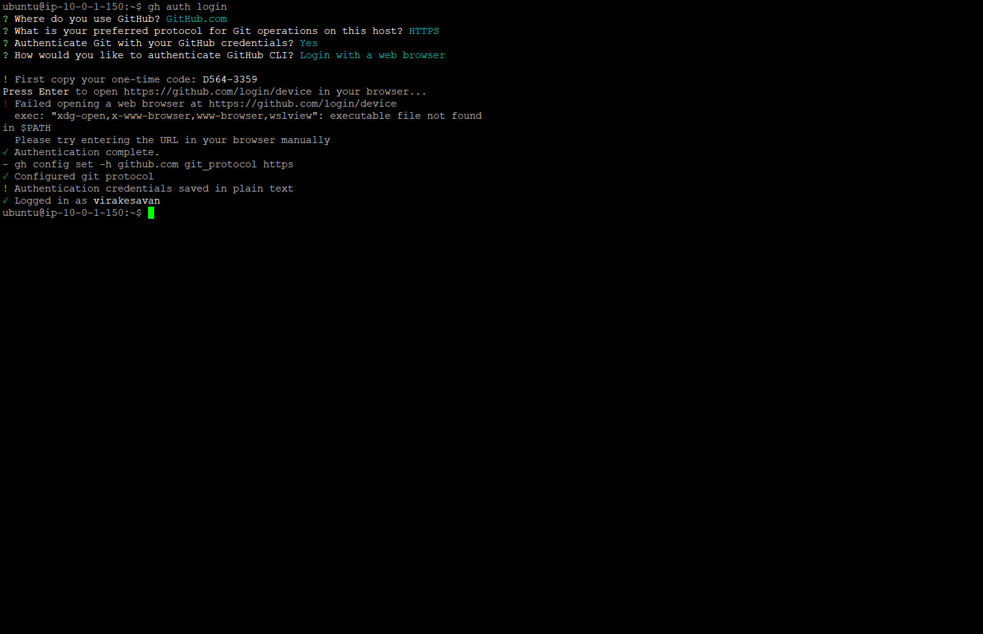
Create Node.js Web Application
Explanation:
We’ll use Express.js to create a simple web app.
Commands:
sudo apt install nodejs npm -y
node -v
npm -v
mkdir node-js-getting-started
cd node-js-getting-started
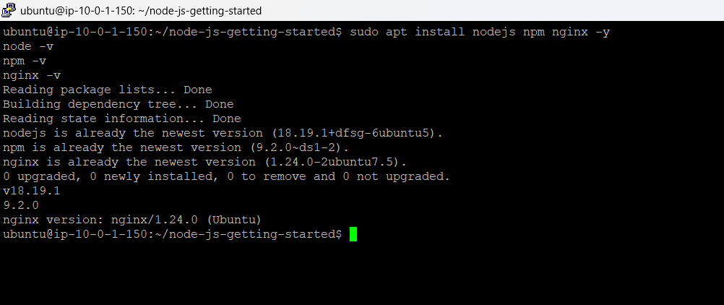
nano index
Modify Node.js Code
Inside index.js, you can modify like this:
const express = require('express')
const path = require('path')
const app = express()

app.listen(5006, function() {
console.log("Listening on port 5006");
});
console.log("File change test!");
console.log("Second file change test!");
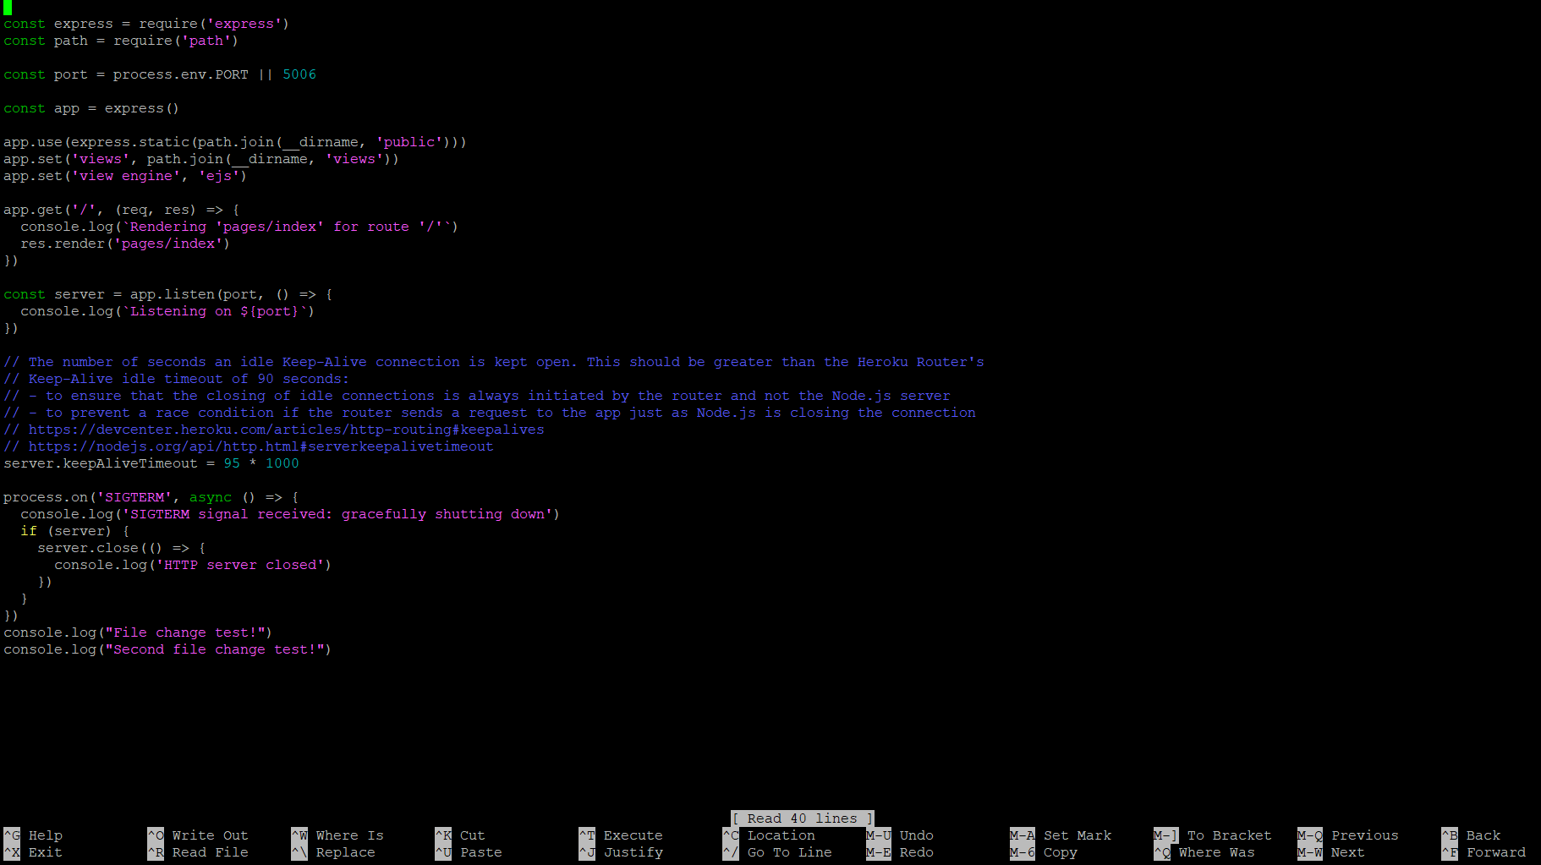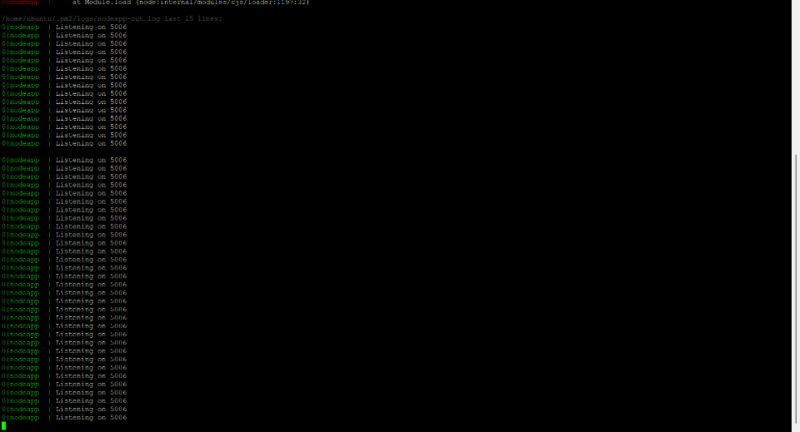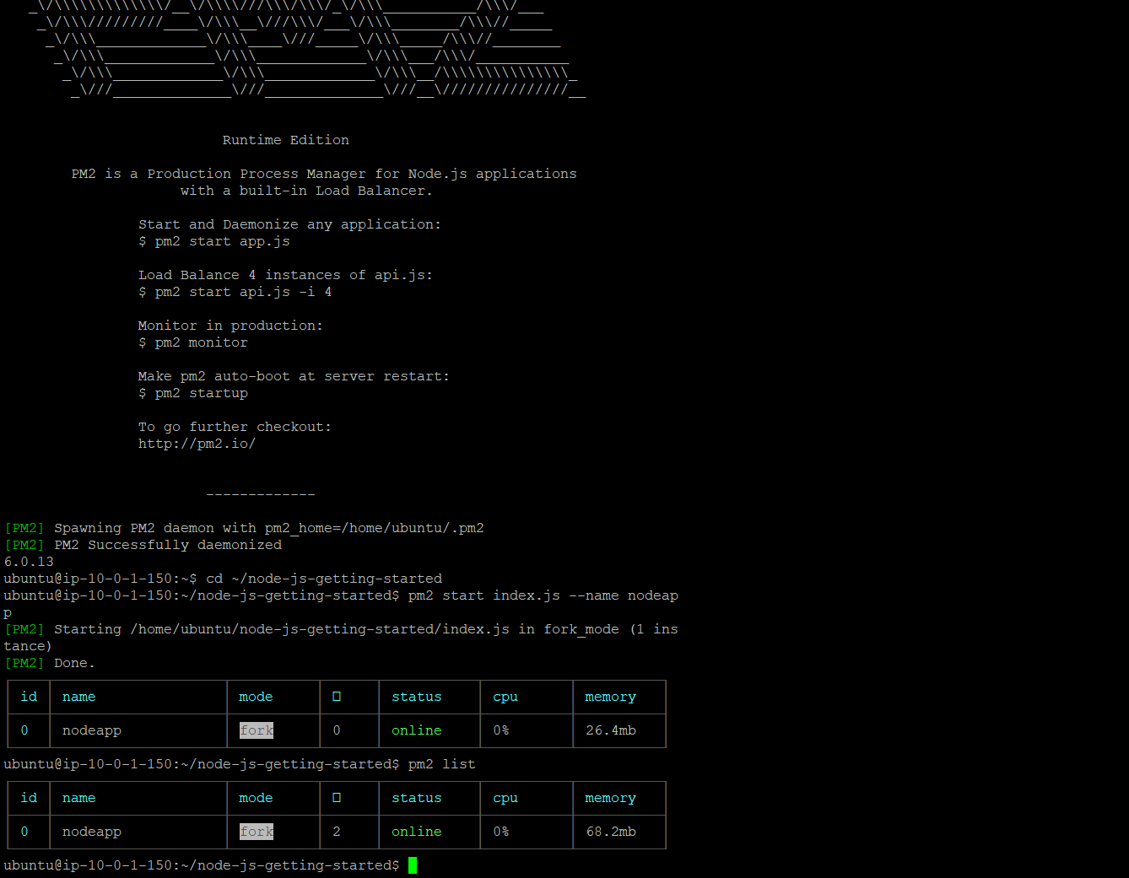

Install and Configure PM2
Explanation:
PM2 keeps your app running in the background and restarts it automatically if it crashes.
Commands:
sudo npm install pm2 -g
pm2 start index.js --name nodeapp
pm2 list
pm2 logs nodeapp
pm2 stop nodeapp
pm2 restart nodeapp
pm2 delete nodeapp
pm2 monit
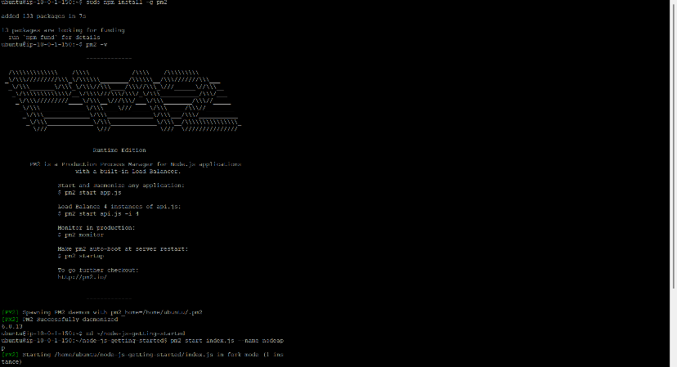
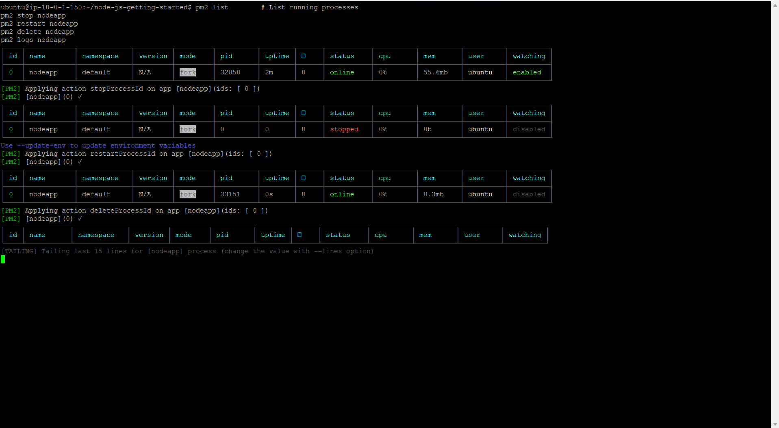

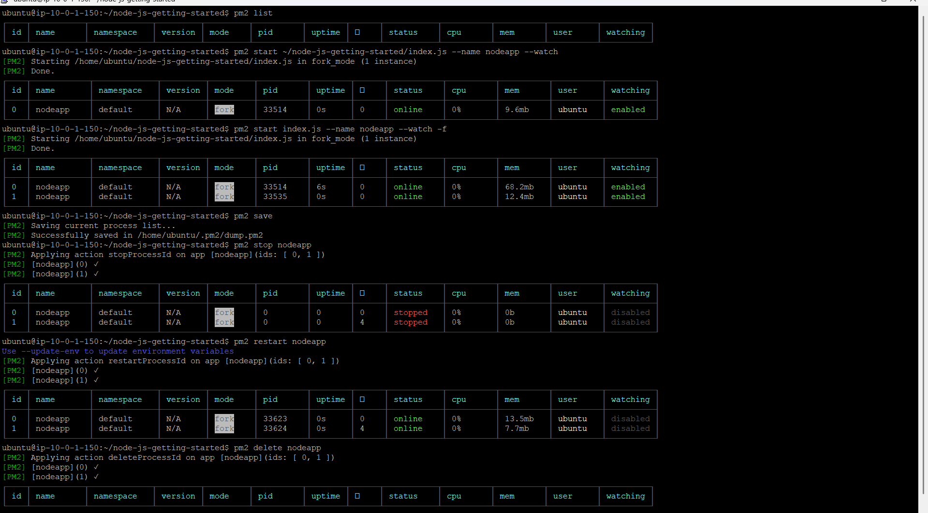
Deploy or Access Web App
Explanation:
Now open your app using the EC2 Public IP.
URL :
http://16.170.140.133:5000

Getting Started Page
Once everything is complete, open:
http://16.171.241.106:5006
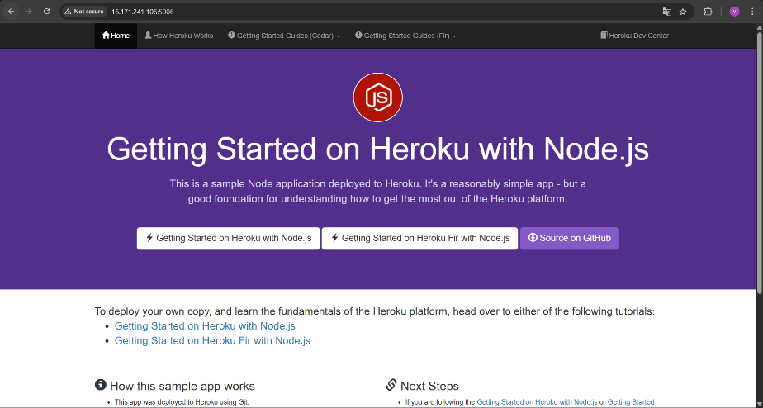
Monitoring and Maintenance
Explanation:
A Cloud Engineer must monitor app health, uptime, and logs.
Commands:
pm2 monit
pm2 logs nodeapp

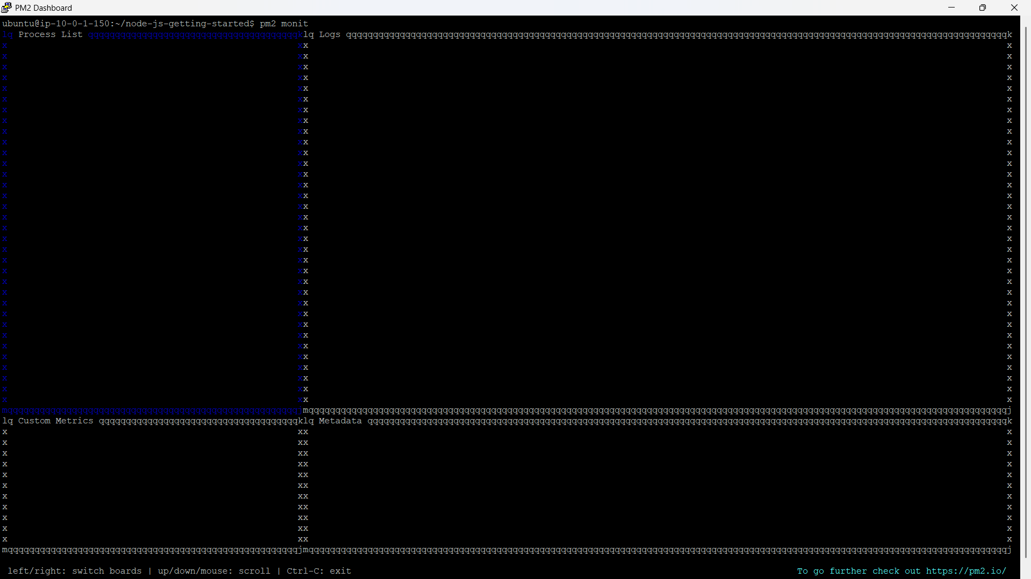
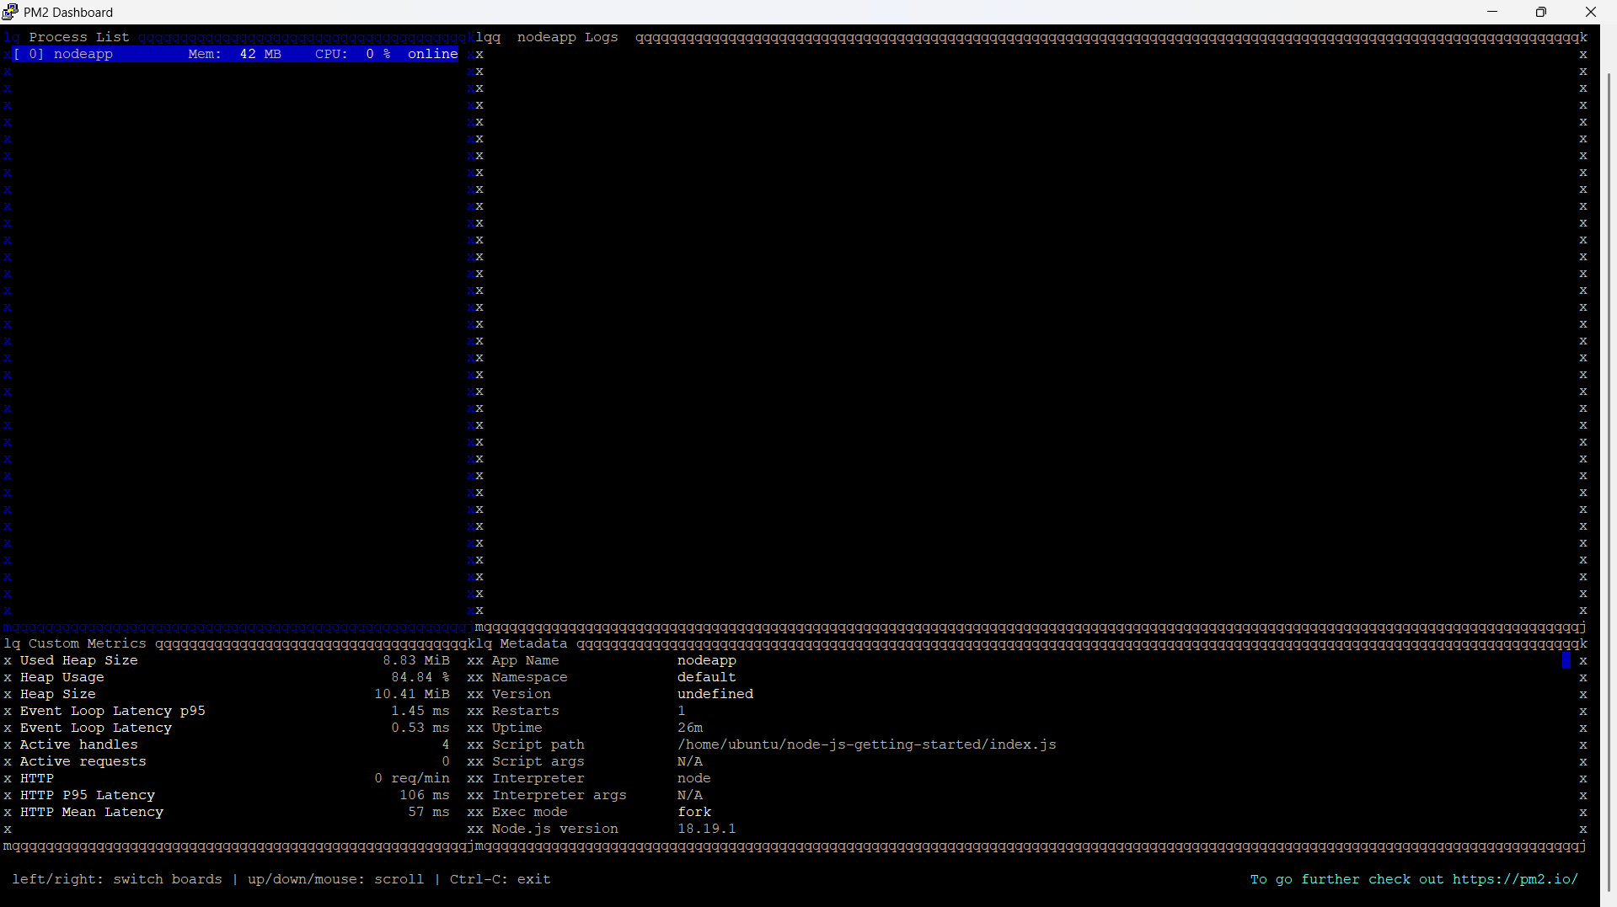
key points:
Configured a secure cloud environment (VPC + EC2)
Installed Docker and deployed a Node.js app
Integrated GitHub for version control
Used PM2 for monitoring and auto-restart
Verified app running in browser

